PHYSICAL PROPERTIES OF AND COMPARISON OF FRUIT QUALITY PARAMETERS OF TAMARINDUS INDICA FROM HOME GARDENS AND MARKET
N.Thasajini¹ and V.Sujarajini²
^{1,2} Department of Biological sciences, South Eastern University of Sri Lanka, Sri Lanka.
thasathasa91@gmail.com
ABSTRACT
Tamarindus indica is widely grown as a subsistence crop for meeting local demands. Tamarind is an economically important multipurpose spice which is grown both as domesticated spices in farmland and as wild in forest lands. Tamarindus indica is a leguminous tree in the family Fabaceae. Tamarind pulp has long been used for many medicinal purposes and continues to be used by many people in Africa, Asia and America. The knowledge about physical properties of any biomaterial is essential to design its equipment for processing, storage, transportation and value addition.

The analysis of physical properties of tamarind pulp which includes length, width, thickness, volume, pulp weight and density was measured for 30 samples. The Standard Deviation (SD) of length, width and thickness of tamarind pulp were found to be 1.69, 0.20, 0.01 and coefficient variation were 17 %, 10.3%, 11.24% respectively. The SD and coefficient of variance for weight of fruit pulp were calculated to be 0.24 and 12.20% respectively. The SD and coefficient of variation for density of fruit pulp were found to be 1.21 and 12.34%.
Fruits were collected from home garden and market for comparison of fruit quality parameters. Total soluble solids (TSS), Titratable acidity and ph for fruits collected from home garden were 38.2º Brix, 22.4% and 2.4 ± 0.1 while 33.8º Brix, 21.1% and 2.6± 0.1 were observed in fruits collected from market. Moisture content, ash content, wax content of home garden fruits were 12.80±0.22%, 2.15±0.12%, 1.93±0.52% while 15.41±0.35%, 2.19±0.20%, 2.05% were observed for fruits collected in market. Moisture content and ash content were also high in fruits collected from market. Based on the fruit quality parameters including taste, fruit quality was high in fruits collected from home garden.

Keywords
Tamarind, Total Soluble Solids, Titratable Acidity, home garden, moisture content and fruit pulp.

- INTRODUCTION

Tamarindus indica, is a multipurpose tropical fruit tree used primarily for its fruits, which are eaten fresh or processed, used as a seasoning or spice, or the fruits and seeds are processed for non-food uses. The tree averages 20-25 m in height and 1 m in diameter, slow growing, but long lived, with an average life span of 80-200 years. Virtually every part of Tamarindus indica has either nutritional or medicinal value, with a number of industrial and commercial applications (Emmy et al., 2010).

The fruit pulp is also said to aid in the cure of malarial fever (Timyan, 1996) and typically contains 20.6% water, 3.1% protein, 0.4% fat, 70.8% carbohydrates, 3.0% fibre and 2.1% ash (Siddhuraju, 2007).Tamarind trees produce an abundance of long, curved, brown pods filled with small brown seeds, surrounded by a sticky pulp that dehydrates naturally to a sticky paste. The fruit pulp is an excellent source of sugars and vitamin B, in addition to minerals and phenolic compounds as antioxidants (Ajayi et al., 2006). Tamarind is particularly useful for managing pain and inflammation on joints. (Joshua and Dudhade, 2006

Tamarind can be the most acidic and sweet fruit according to its growing season (Caluw et al., 2010). The pulp is composed of tartaric acid, citric acid and malic acids, potassium bitartarate, pectin, gum and water (Tsuda et al., 1994). In the present situation with increasing population pressure, demand for tamarind pulp has also increased considerably (Singh, 2007).The pulp is descanted form can be stored well for extended period without refrigeration due to its high acid content which acts as a natural preservative against microorganisms.

Flavonoid and other polyphenols are metabolites that have been found in tamarind leaves. These compounds have recorded as antimicrobial agents in many other plants. Tamarind mostly used as two different varieties they are sweet and sour. Sweet tamarind is harvested ripe and directly consumed, sour tamarind is processed into a range of value-added product. Thus, this study was aimed to evaluate morphology, fruit quality and compare these parameters between the plants found in natural ecosystem and home garden.

- MATERIALS AND METHODS
Physical properties of home garden fruit

  - Average Length, Width and Thickness of tamarind pulp

The Tamarind pulps were collected from home garden from periya kallaru arae and local market and stored in room temperature. The analysis of physical properties of tamarind pulp which includes length, width, thickness, volume, pulp weight and density were measured. For each parameter 30 samples were taken randomly and measurements were done separately.

Average Length, Width and Thickness of tamarind pulp was calculated as follows.

L$=\sum_{i=1}^{n}{L/n}$

_{W}$=\sum_{i=1}^{n}{w/n}$

_{T}$=\sum_{i=1}^{n}{T/n}$

Where, L, W, T refers to length (cm), width (cm) and thickness (cm) and n express the number of sample, (n=30)

2.2 Volume of the tamarind pulp
The length, width and thickness of tamarind pulp were measured. The volume of the tamarind pulp was calculated by using the formula:

Volume = L x W x T

2.3 Tamarind pulp mass
The mass of tamarind pulp was measured by the electric balance having least count up to
0.01 g.

2.4 Density of tamarind pulp

The density (D) (g/cm³ ) of the tamarind pulp was calculated by using the formula: $D=M/V$

Where, V indicates volume (cm³ ) and M indicate mass of tamarind pulps.

2.5 Total Soluble Solids (TSS) pH, Titratable Acidity

Total Soluble Solids (TSS) was measured by one drop of fruit juice placed on the refractometer (ATAGO, ATC – 1E made in Japan). pH was measured by using pH meter (PHS–3BW). Titratable acidity was measured by titration. 6g fruit pulp was measured and dissolved in 50ml of water and titrated with 0.1M NaOH.
% acid = [Volume of NaOH used] x [0.1 N NaOH] x [milliequivalent factor] x [100]
Sample weight
2.6 Moisture and Ash contents
Moisture content was determined using hot air oven (OV9 SCF, Serial No 98K074) method. 5 g of three samples were kept in an oven for 3 days at 105ºC. Weight loss on drying to a final constant weight was recorded as moisture content by AOAC (1984) recommended method.
Dry weight sample obtained from oven was kept in furnace (HD-230, OBERSAL) at 560°C for 6 hours. Final weight was measured to determine ash content (AOAC, 1990).
2.7 Wax content
5g each of separate samples were dissolved in 10ml of ethanol. It was shaked for 1 hour. Then it was placed in fume hood for evaporation. Final weight was weighed after 24 hours to determine wax content.

3 Results and Discussion
Physical properties of home garden fruits
  - Average length, width and thickness of fruit pulp
Table 1. Physical property of Tamarindus indica fruit

Parameters | Average | Range | Standard deviation (SD) | Co – efficient of variation (CV%)
Length (cm) | 9.59 | 5.9 -12.3 | 1.69 | 17
Width (cm) | 2.01 | 1.7-2.4 | 0.20 | 10.3
Thickness (cm) | 0.112 | 0.092-0.132 | 0.01 | 11.24
Weight (g) | 6.63 | 6.56-7.02 | 0.24 | 12.20
Volume (cm³) | 2.15 | 2.21-2.34 | 1.50 | 22.02
Density (g/cm³) | 3.08 | 3.06-3.11 | 1.21 | 12.34

The ranges of length of tamarind pulp were found to be 5.9 to 12.3 cm with an average length of 9.59 cm. The SD and coefficient of variance was found to be 1.69 and 17 % respectively. The width of the tamarind pulp was found to be in the range of 1.7 to 2.4 cm and the average width was found to be 2.01 cm. The SD and coefficient of variance was found to be 0.20 and 10.3% respectively. The ranges of thickness of tamarind pulp were found to be 0.092 to 0.132 cm with an average thickness of 0.112 cm. The SD and coefficient of variance was calculated to be 0.01 and 11.24% respectively.
3.2 Volume of the tamarind pulp
The volume of tamarind pulp was also presented in Table 1. The volume was found to be 2.15cm³ on average of 30 tamarind pulps. The SD and coefficient of variation for volume was found to be 1.50 and 22.02%.
3.3 Weight of tamarind pulp
The table shows that the weight of tamarind pulps was found to be in the range of 6.56 to 7.02g and the average weight of 6.63 g. The SD and coefficient of variance was calculated to be 0.24 and 12.20% respectively. Wide variation for pulp weight ranging from 2.70 to 9.18 g. (Benjamin and Seegobin, 1999)
3.4 Density of tamarind pulp
The density of tamarind pulp are also presented in Table 1. The true density was found to be 3.08 g/cm³ on average of 30 tamarind pulps. The SD of density and coefficient of variation were found to be 1.21 and 12.34%.
3.5 Measurement of fruit parameters for home garden fruits and Market fruits

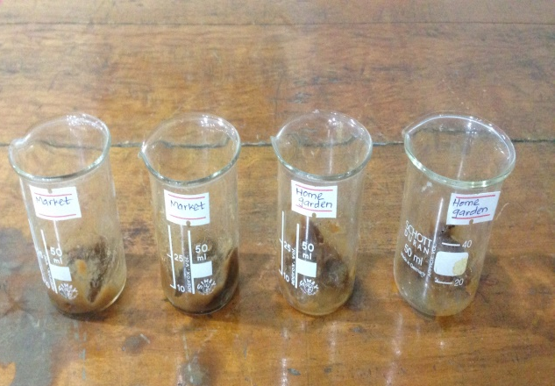
Seeds were removed and fruit pulp was extracted by grinding.

Figure 1. Fruit pulp from home garden fruit and market fruit.

Table 2. Comparison of fruit parameters for fruits collected from Home garden and market.

Fruit parameters | Home garden | Market
TSS (º Brix) | 38.2 | 33.8
pH | 2.4 ± 0.1 | 2.8± 0.1
Titratable Acidity % | 22.4 | 21.1

High TSS value was observed in fruits collected from home garden. Titratable acidity was also high in home garden fruits so it contain high amount of H⁺ ions and low pH. Acidity was reduced during storage growth on attainment of maturity and ripening. The results of the pH variation might be possibly due to genetic dissimilarities of plants between two ecosystems. (Upadhyay et al., 1991)

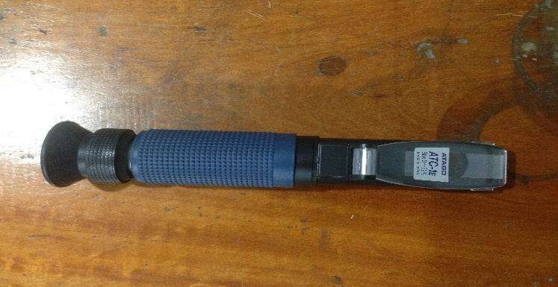

Figure 2 .Measurement of Total Soluble Solid by Refractometer
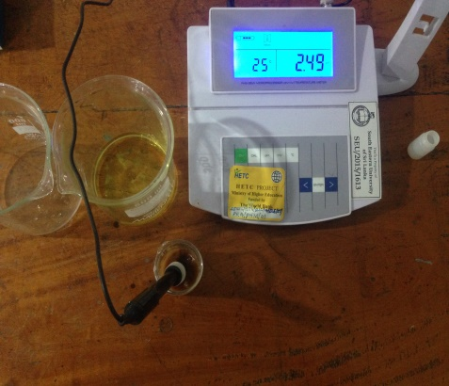

Figure 3. Measurement of pH of fruit pulp by pH meter

3.6 Moisture and ash content
Table 3. Comparison of Moisture content for fruits collected from Home garden and Market.

Home garden | Market
MH1- 12.34% | MM1- 15.02%
MH2- 12.67% | MM2- 15.67%
MH3- 12.88% | MM3- 15.83%

Table 4. Comparison of Ash content for fruits collected from Home garden and Market.
Home garden | Market
AH1- 2.18% | AM1- 2.45%
AH2- 2.67% | AM2- 2.76%
AH3- 2.34% | AM3- 2.66%
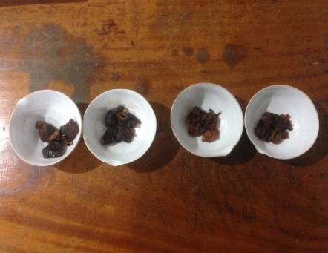

(A) (B)

Figure 4. Samples from Home garden (A) and Market (B) for the measurement of moisture and ash content.

The moisture content, on fresh weight basis, of seed samples was higher than the value of 9.4% and lower than the range 11.4%-22.7% (Marangoni et al., 1999). High moisture content was observed in fruits collected from Market. The fruits from market were collected from Natural ecosystem with high optimal growth conditions including rain fall, temperature, light and humidity. High ash content was observed in fruits collected from forest ecosystem this is due to high amount of nutrient availability in natural ecosystem than home garden ecosystem.

3.7 Wax content

Table 5. Comparison of wax content for fruits collected from Home garden and market.
Home garden | Market
WH1- 2.45% | WM1- 2.18%
WH2- 2.76% | WM2- 2.67%
WH3- 2.66% | WM3- 2.34%

CONCLUSION
Tamarindus indica has a high use value in the study area evidenced by multiple uses. Indigenous knowledge and uses concurred with scientifically proven nutritional and medicinal attributes of Tamarindus indica in literature which is significant given current trends towards affordable functional foods. The knowledge of important physical properties such as length, breadth, thickness, weight, volume, density and colour is necessary for design of tamarind processing machines. For designing and development of machine the length, width and thickness of tamarind are important for dehulling and deseeding machine.
Chemical properties and fruit quality parameters such as TSS, pH, Titratable acidity ,moisture content, ash content and wax content are much important for the comparison of fruit quality. As the availability of growth conditions are optimum in natural ecosystem, high TSS, moisture and ash content were observed in fruits collected from Natural ecosystem.

REFERENCES
- Ajayi, I., Oderinde, R.A., Kajogbola, D.O., Uponi, J.I. (2005) Oil content and fatty acid composition of some underutilized legumes from Nigeria. Food Chem, 99, 115-120. doi: 10.1016/j.foodchem.06 - 045.
- AOAC. Official Methods of Analysis. (2005) 18th edn. Association of Official Analytical Chemists; Arlington, VA, USA.
- Benjamin, E. and Seegobin, D. (1999) Preliminary investigations on the characterization and evaluation of tamarind Empowering farmers through agricultural research, Proceedings of Research Division, Ministry of Agriculture, Land and Marine Research Seminar Series held at Centeno, Trinidad and Tobago, pp 89-98.
- Bourou, S., Bowe, C., Diouf, M., Van Damme, P. (2012) Ecological and human impacts on stand density and distribution of Tamarindus indica in Senegal. Afr J Ecol.F; 50(3):253–380.
- Caluw, E., Halamov, K., Van Damme, P. (2010) Tamarindus indica: a review of traditional uses, phytochemistry and pharmacology. Afrika Focus; 23(1): 53-83.
- Challapilli, A. P. (1992) Studies on evaluation of elite tamarind (Tamarindus indica L) types for quality, yield and multiplication by air layering. Unpublished Thesis, University of Agricultural Sciences, Dharwad. pp. 71-73.
- Ebrahim, H.M. (2012) Plant architectural traits and their role in defense mechanism aginst malformation in mango.
- Siddig, K., Ebert, G., Ludders, P. (1999) Tamarindus indica: a Review on a Multipurpose Tree with Promising Future in the Sudan. Journal of Applied Botany, 73; 202-205.
- Emmy, D.C., Halamova, K., Damme, P.V. (2010) Tamarindus indica: A review of traditional uses, photochemistry and pharmacology ; 23(1); 82.
- Havinga, R.M., Hartl, A., Putscher, J., Prehsler, S., Buchmann, C., Vogl, C.R. (2010) Tamarindus indica: patterns of use in traditional African medicine. J Ethnopharmacol. 127:573–588. doi: 10.1016/j.jep.11.028.
- Joshua, D., Dudhade, P. (2006) Analysis of economic characteristics of value chains of three underutilised fruits of India. Southampton, The International Centre for Under utilised Crop: 22.
- Naveena, K., Patgiri, B.J., Harisha, C.R., Shukla, V.J. (2012) Pharmacognostical and physicochemical analysis of Tamarindus indica Journal of Ayurveda & Integrative Medicine ;3(1):6
- Siddhuraju, P. (2007) Antioxidant activity of poly phenolic compounds extracted from defatted raw and dry heated Tamarindus indica seed coat, 40, 982-990.
- Singh, D., Wangchu, L. and Mood, S. K. (2007) Processed Products of Tamarind. Natural Product Radiance 6(4):315-317.
- Timyan, J. (1996) important trees in Haiti, Washington, Southeast Consortium for International Development, 418p.
- Tsuda, T., Watanabe, M., Ohshima, K., Yamamoto, A., Kawakishi, S., Osawa, T. (1994). Antioxidative Components Isolated from the Seed of Tamarind .Journal of Agricultural and Food Chemistry, 42, 2671-2674.
- Upadhyay, I.P.,Noomhorm, A. and Ilangantileke, S.G (1994) “Effects of gamma irradiation and hot water treatment on the shelf life and quality of Thai mango cv Red,” The Australian Centre for International Agricultural Research, pp. 348–351.

